**Day 1 –May 30 (Thursday)**

**Depart USA**

* departs JFK

**Day 2 – May 31 (Friday)**

• Arrive in Israel at Ben Gurion Airport - Tel Aviv and board our tour bus. (IF flights are on time)

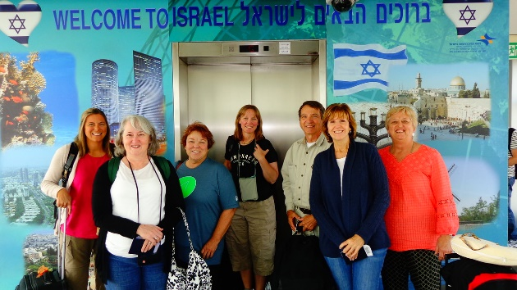

* **Caesarea –** site of one of Herod’s magnificent and opulent palaces, but most importantly, it is the Mediterranean port from which the Apostle Paul departed on his missionary journeys.
* **\*\*\*\*\* If arrive early enough to do – If not – Sat. Morning before Church**

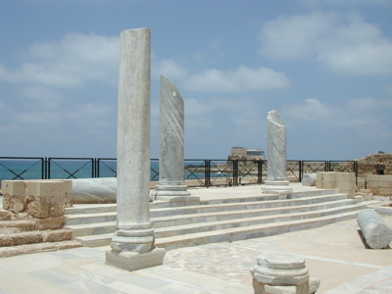

* **Joppa –** short walk through the streets of Old Joppa- Jonah fled the call of God from here. Peter saw the vision that led to his going to Caesarea to share the gospel with Cornelius.

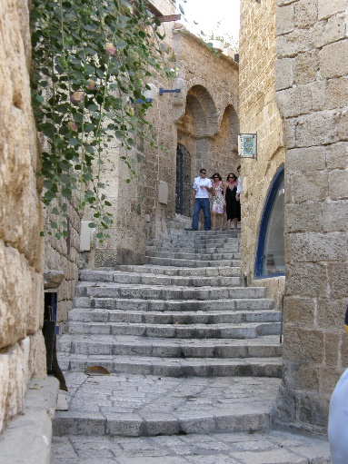

* **Dinner**
* **Overnight: Haifa–** Port city located at the base of Mt. Carmel.

**Day 3 –June 1 (Saturday)**

• **Breakfast at the hotel ~ Check-out and board bus**

* **Caesarea –** site of one of Herod’s magnificent and opulent palaces, but most importantly, it is the Mediterranean port from which the Apostle Paul departed on his missionary journeys. ****** **If did not arrive early enough to do, yesterday – do before Church**
* **Mt. Carmel Assembly: Attend church service for Carmel Assembly of God…10:45 AM – 12:00 noon**

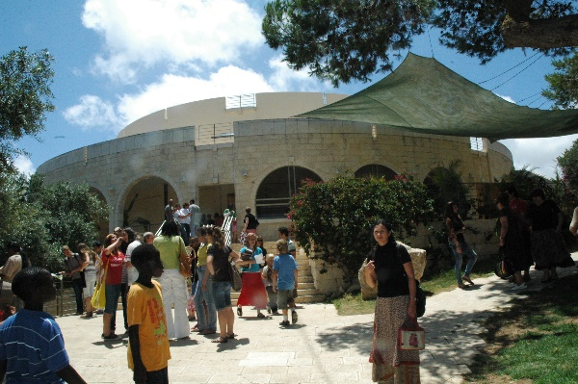

* **Mt. Carmel - Best known for the contest between the Prophets of Baal and the Prophet Elijah in 1 Kings 18:19-20.**

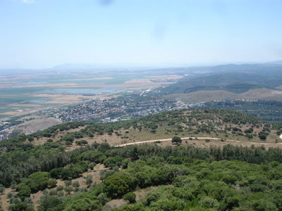

* **Galilee**
* Smyrna
* **Shabbat dinner**
* **Dinner & Overnight: Galilee**

**Day 4 – June 2 (Sunday)**

• **Breakfast at the hotel**

**Mt. Gerizim, the “Mount of Blessing”** is the center of the present day Samaritan community. Visit the archaeological excavations and Samaritan Museum.

**The Tura Winery** award-winning, boutique wineries provide a glimpse into the wine-making industry, a craft that goes back to the Biblical period in this area. Owned & operated by Jewish family as part of fulfillment of prophecy.

* **Shiloh – where Samuel grew up at the Tabernacle**
* **Praying for Israel’s north borders**, either at Misgav Am or Metula or Syrian border side view towards Qunetra .
* **Dinner & Overnight**

**Day 5 – June 3 (Monday)**

• **Breakfast at the hotel**

• **Sail across the beautiful Sea of Galilee**

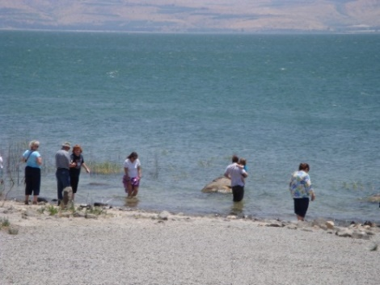

**“Jesus Boat” Museum/** Yigal Alon Museum

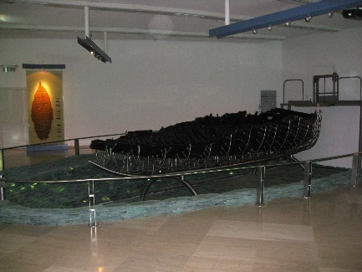

• Mt. of Beatitudes

* **Capernaum** - The fishing village which served as home during Jesus' Galilee ministry

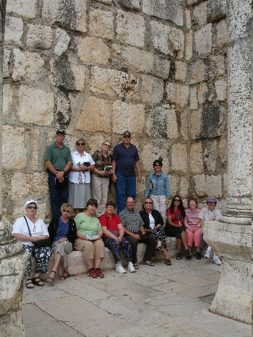

* Lunch at **St. Peter’s Fish** Restaurant ~ You’ll have the opportunity to enjoy fish caught in the Sea of Galilee earlier in the morning (not part of trip cost).

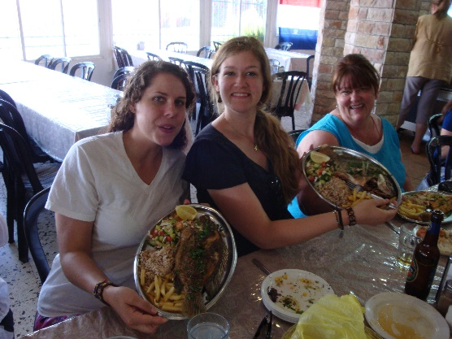

**• New Museum: Magdala**

* **Return Center – see the work Christians are doing to help people who are making alyiah**
* **Dinner & Overnight in Galilee. Ron Beach**

**Day 6 – June 4 (Tuesday)**

* **Breakfast at the hotel**
* **Yardenit** - Experience baptism at Yardenit, in the Jordan River, located at the southern tip of the Sea of Galilee (if you want to be baptized, you may rent a gown here/ with the rental comes a certificate).

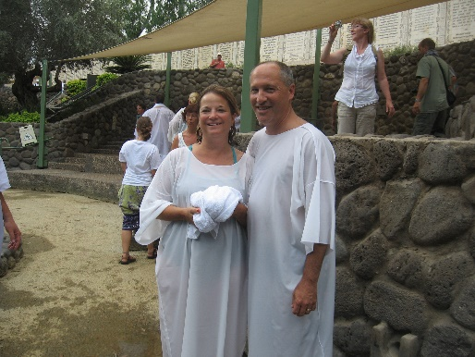

**• Jericho –** Oldest city in the world

* **Qumran** - This area is the location of the caves where the Dead Sea Scrolls were found by a young shepherd boy. Legend has it John the Baptist once studied here with the Essences.

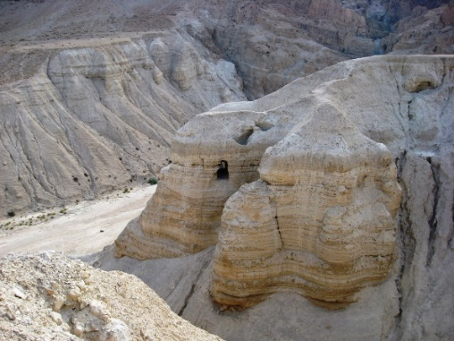

• **En Gedi** - was a source of renewal and strength for David and his men as they fled King Saul. David would replenish in the Living Waters of En Gedi as we replenish in the Living Waters of God's Word. As a deer panteth after the water brooks, so my soul panteth after thee, my God. (Psalms 42:2)

• **Dead Sea** - The warm waters of the Dead Sea with the salt content 28 - 30 times stronger than any ocean is said to offer many medicinal remedies.Jump in and see if you can sink.

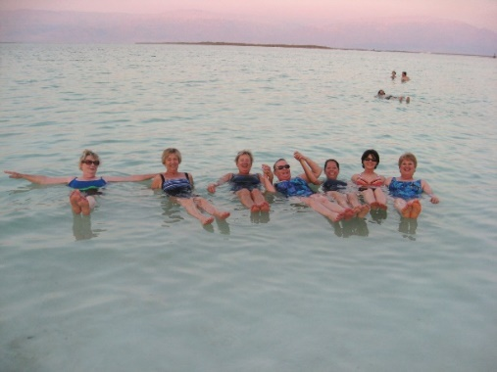

**• Dinner & Overnight: Dead Sea**

**Day 7 – June 5 (Wednesday)**

• **Breakfast at the hotel ~**

* **Exploring the Negev Desert ~** Israeli desert agricultural research has concentrated on developing new technologies that enable farmers to use brackish (salty) water for agricultural irrigation, something which had never been done before in any other place in the world. The Negev Desert has very little fresh water but an almost unlimited underground supply of brackish water, now used extensively for agriculture. Since brackish water is abundant in most desert areas of the world, the Israeli techniques have broad international applications.
* **Dinner & Overnight: Retreat in the Desert**

**Day 8– June 6 (Thursday)**

• **Breakfast ~ Check out of hotel and board bus**

* **Be’er Sheva –**Where Abraham lived and dug 7 wells.

• **Archeological Dig at Bet-Govin National ~** The people who lived at Beit Govrin thousands of years ago left behind plentiful testimony to their existence both above and below ground. Among the sites are a Roman amphitheater and Beit Govrin [National Park](http://www.goisrael.com/Tourism_Eng/Articles/Attractions/Pages/National%20Parks%20and%20Nature%20Reserves.aspx) ,Tel Mareshah, which was fortified by Solomon’s son Rehoboam (2 Chron. 11:8).

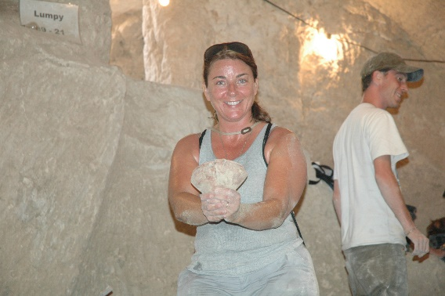

* **Bell Caves –** story inside these caves is a great contrast to the beauty of them
* **Jerusalem overlook ~** a view of the old city of Jerusalem.
* **Outdoor movie at City of David (optional, not included in trip cost)**
* **Dinner & Overnight: Jerusalem**

**Day 9 – June 7 (Friday)**

• **Breakfast ~ board bus**

* **The Israeli Museum** with the Jerusalem Miniature from the days of King Herod and The Shrine of Books (the Dead Sea Scrolls presentation).

• **Yad Vashem** – The home for the Holocaust Martyrs and Heroes. While heading to our next destination we will pass by the Government Center and the Knesset – Israel’s Parliament

* **City of David -** The story of the City of David began over 3,000 years ago, when King David left the city of Hebron for a small hilltop city known as Jerusalem, a tour through the City of David brings visitors face to face with the personalities and places of the Bible.  This is the only place on earth where the only guidebook needed is the Bible itself.

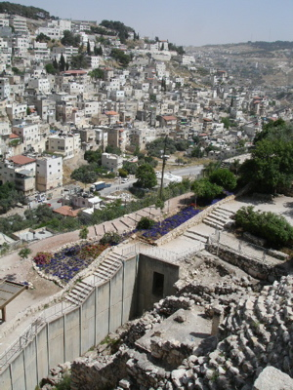

* **Hezekiah’s Tunnel ~** Built during the time of King Hezekiah**.**  Walk through, exiting at
* **Pool of Siloam ~** Site of healing of blind man.

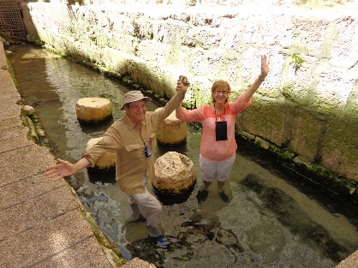

• **Dinner & Overnight: Jerusalem**

1-866-599-6674 1-866-599-6674 1-866-599-6674**Day 10 – June 8 (Saturday)**

• **Breakfast at the hotel**

* **Mt. of Olives** - The first stop will be the Mt. of Olives where Jesus ascended into heaven. Take a moment to reflect back to that day and time while your eyes gaze upon the panoramic view of the Holy City. The presence of God is all about, cast your eyes toward the Eastern Gate, and envision the triumphant return of our Lord in all His glory.

• **Garden of Gethsemane** - Pray among the olive trees as the Lord did nearly 2,000 years ago. What an impact this very night has had on the world when the Son of God submitted to the will of his Father.

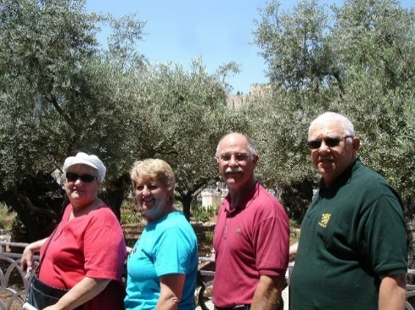

* Via Delarosa ~ the way of the cross.
* **Garden Tomb** - As Jesus was led through the Damascus Gate, he struggled toward Golgotha (Gordon's Calvary), where He was crucified for all sinners. He was buried in the Garden Tomb, from which he arose after the third day. Victory over hell, death and the grave is ours, because He has risen.
* **Bethleham – birthplace of Jesus**

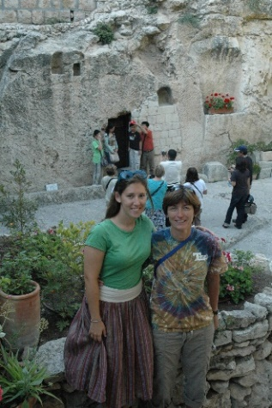

**After Dinner:**

• **Rabbi Tunnel** - This tunnel runs underground along the base of the Temple Mount. We will have a wonderful tour and learn how the stone were crafted and moved into place to create the amazing foundation of Temple Mt. (optional – not part of trip cost)

* **Western Wall at night**

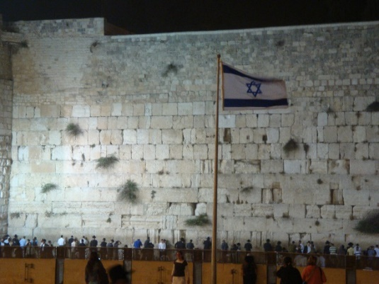

**Overnight: Jerusalem**

**Day 11 – June 9 (Sunday)**

• **Breakfast at the hotel**

* **Temple Mt. – where the 1st and 2nd Temple stood.**
* **Pool of Bethesda** – where Jesus healed.

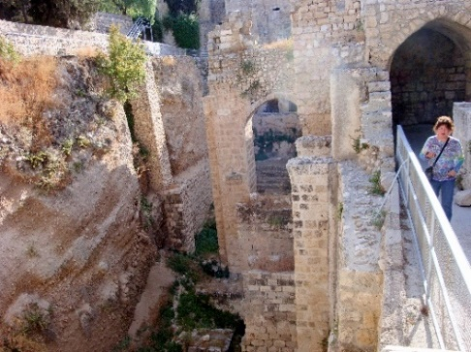

* **US Embasy –** Here the story behind the building as well as see history in the making
* **Prayer room over Jerusalem** – 24/7 people are praying here for the peace of Jerusalem
* Depart for **Ben Gurion Airport –late flight**
* Dinner at Airport – on your own

**Day 12 – June 10 (Monday)**

* depart TLV
* Arrive in USA/JFK